**Task 5**

6 *×* 2 = 10 *marks*

**Name and Registration number: 22BCE3799 Apurba Koirala**



**The task files should have handwritten flow chart/Algorithm, and written Program, Snapshot of typed program and Snapshot of output.**

1. Write an assembly language program to generate a square wave of 1KHz with 20% duty cycle using timer programming.

Written code and flowchart

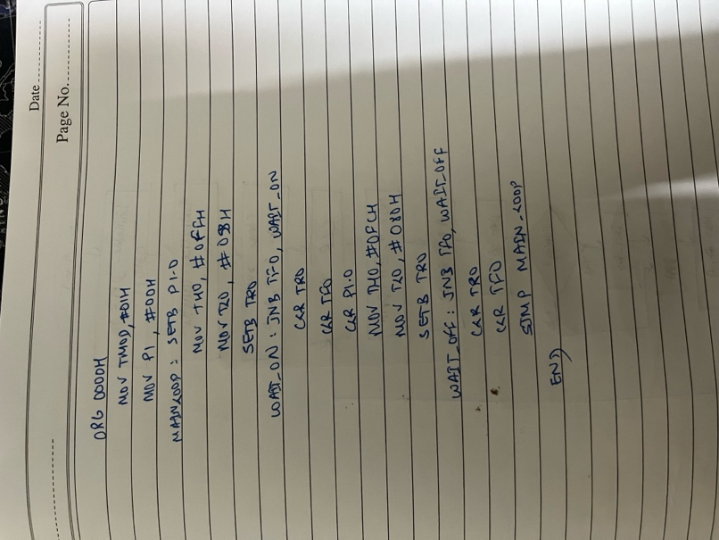

Code and Output:

ORG 0000H

MOV TMOD, #01H

MOV P1, #00H

MAIN_LOOP:

SETB P1.0

MOV TH0, #0FFH

MOV TL0, #058H

SETB TR0

WAIT_ON:

JNB TF0, WAIT_ON

CLR TR0

CLR TF0

CLR P1.0

MOV TH0, #0FCH

MOV TL0, #080H

SETB TR0

WAIT_OFF:

JNB TF0, WAIT_OFF

CLR TR0

CLR TF0

SJMP MAIN_LOOP

END

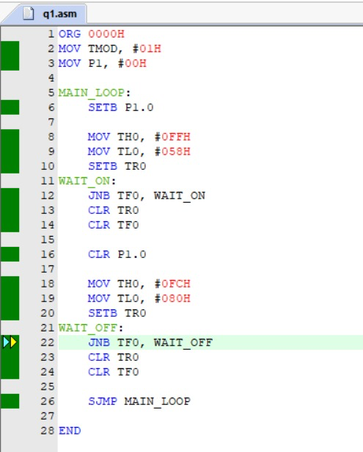

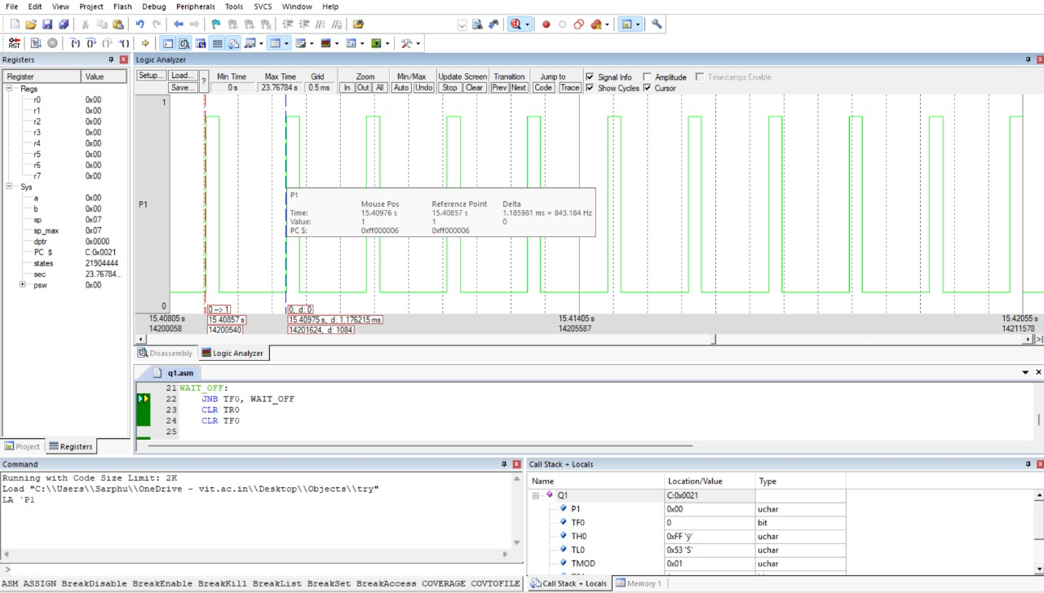

1. Write an assembly language program using interrupts to do the following operations simultaneously: (a) Receive the data serially and send it to P1 (b) Have port P0 read and transmitted serially and a copy given to P2 (c) Make Timer 0 to generate a square wave of 3KHz frequency on P1.1. with 66.67% duty cycle. Assume that XTAL = 11.0592Mhz. Set the baud rate at 4800.

Code:

ORG 0000H

MOV TMOD, #01H

MOV P1, #00H

MAIN_LOOP:

SETB P1.0

MOV TH0, #0FFH

MOV TL0, #058H

SETB TR0

WAIT_ON:

JNB TF0, WAIT_ON

CLR TR0

CLR TF0

CLR P1.0

MOV TH0, #0FCH

MOV TL0, #080H

SETB TR0

WAIT_OFF:

JNB TF0, WAIT_OFF

CLR TR0

CLR TF0

SJMP MAIN_LOOP

END